Project Design Phase-II
Technology Stack (Architecture & Stack)
Date | 08 October 2026
Team ID | 9100SmartGirls
Project Name | Streamlining IT Procurement: Automating Standard Laptop Orders with Flow Designer
Maximum Marks | 4 Marks

Technical Architecture:
The Deliverable shall include the architectural diagram as below and the information as per the table1 & table 2
Example: Automatic configuration task creation for standard laptop orders on a ServiceNow instance
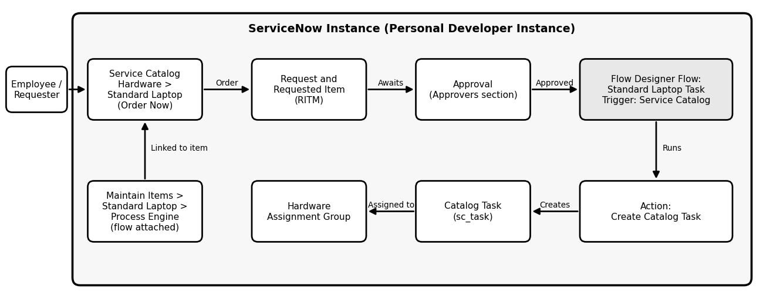
Table-1 : Components & Technologies:
S.No | Component | Description | Technology
1 | User Interface | Catalog item through which the user orders the laptop | ServiceNow Service Catalog (Hardware > Standard Laptop > Order Now)
2 | Application Logic-1 | Detects the laptop order | Flow Designer trigger: Service Catalog
3 | Application Logic-2 | Creates the configuration task for the Requested Item | Flow Designer action: Create Catalog Task
4 | Application Logic-3 | Sets Short Description, Description, Assignment Group (Hardware) and Approval (Approved) | Create Catalog Task field values
5 | Flow Assignment | Links the flow to the Standard Laptop item | Maintain Items > Process Engine
6 | Approval | Approves the laptop request | Approvers section of the Request record
7 | Database | Stores the request, requested item and catalog task records | ServiceNow tables: Request, Requested Item, Catalog Task [sc_task]
8 | Flow Properties | Defines the scope and the user the flow runs as | Application: Global; Run As: System User
9 | Platform | Hosts all components | ServiceNow instance (Personal Developer Instance)

Table-2: Application Characteristics:
S.No | Characteristics | Description | Technology
1 | Open-Source Frameworks | No open-source framework is used. The solution is built with the no-code tools provided by ServiceNow. | ServiceNow platform tools
2 | Security Implementations | Requests are approved by an approver from the Approvers section, and the flow runs as System User. | ServiceNow approvals and Run As setting
3 | Scalable Architecture | Similar flows can be created for other catalog items and attached through Process Engine. | Flow Designer, Service Catalog
4 | Availability | The solution runs inside the ServiceNow instance and depends on its availability. | ServiceNow instance
5 | Performance | The flow creates the catalog task automatically without manual steps. | Flow Designer Service Catalog trigger

References:
https://docs.servicenow.com
https://developer.servicenow.com

